7.Demonstrate how a JUnit sampler script is run in JMeter.

* Create a Java package in eclipse🡪 create a Junit class and add Junit test annotation🡪 create a junit method.
* Add Junit 4 library in the java project.

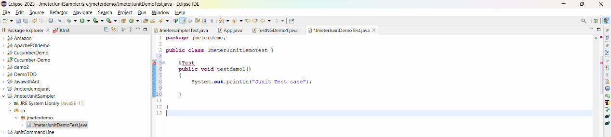

Select Junit 4 library

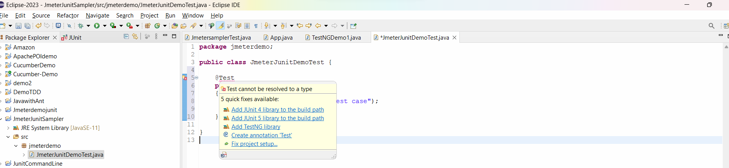

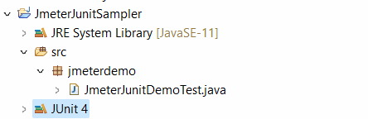

* Next we have to export this Project of junit into a Jar file, so that jmeter can execute it.
* Right click on project🡪 select export 🡪 select Jar

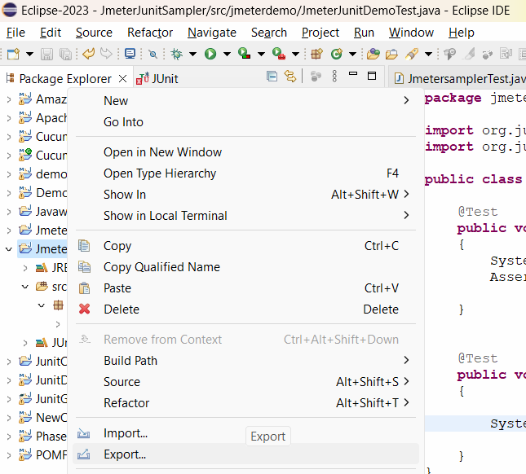

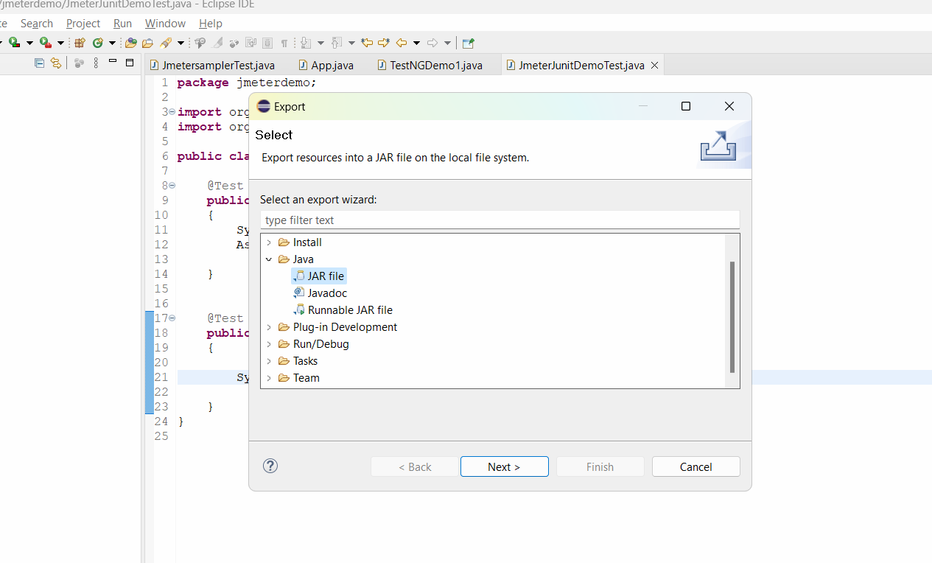

* Press next and select the export destination 🡪 Click on browse🡪 the path with jmeter/lib/junit folder -> C:\Users\Ashu\Downloads\apache-jmeter-5.6.2\apache-jmeter-5.6.2\lib\junit

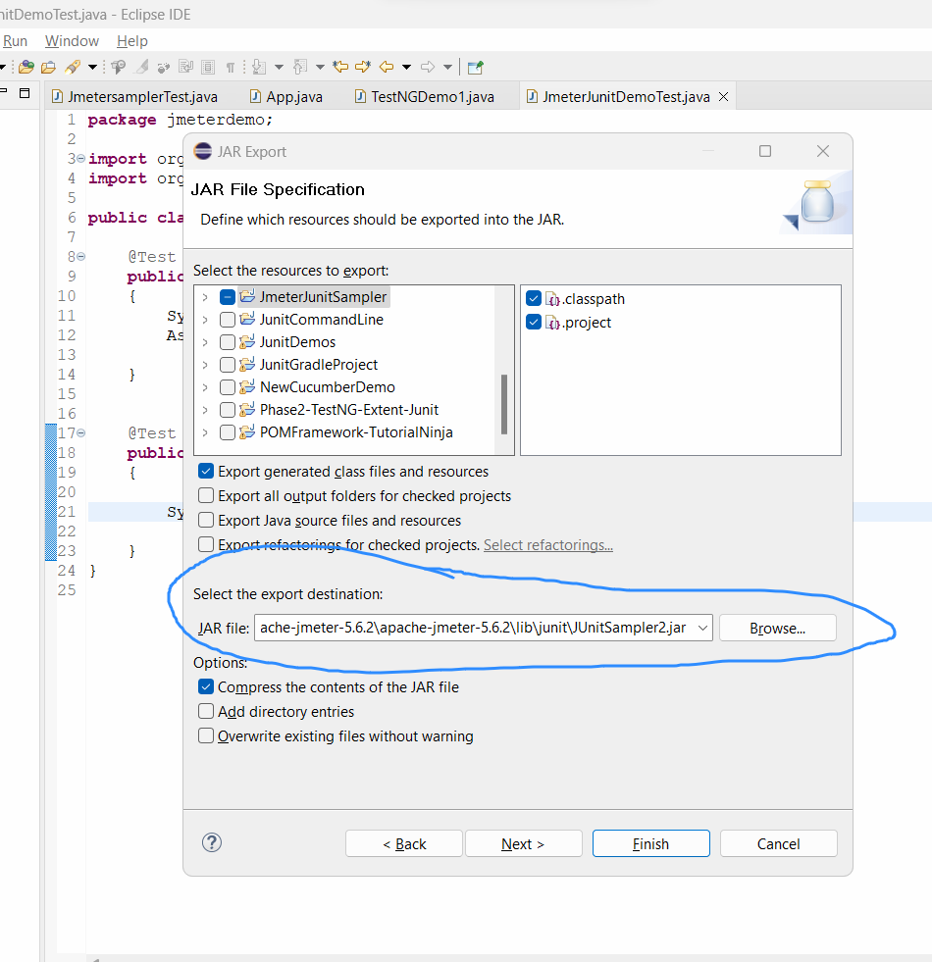

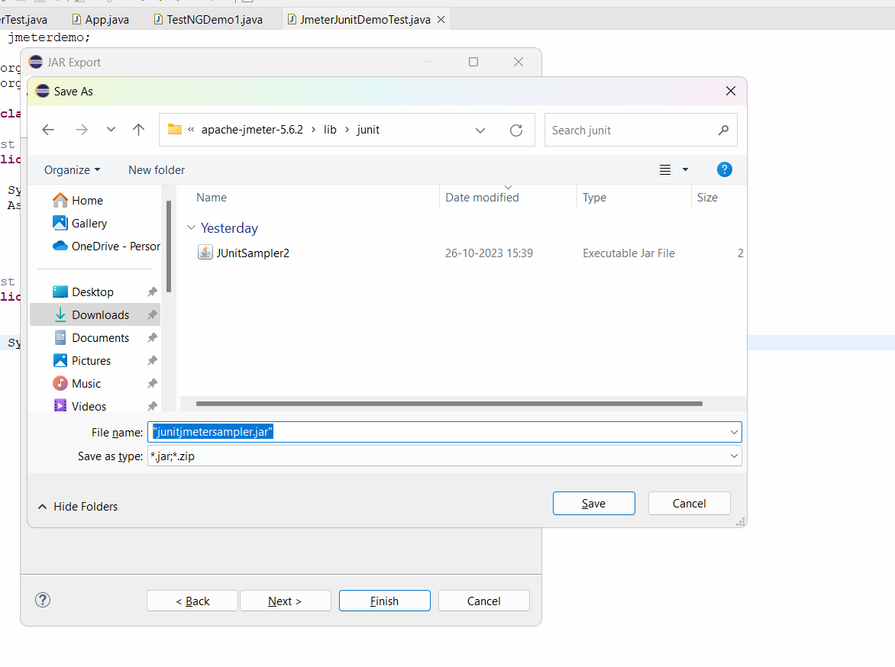

* Click on save and finish button.
* Close and restart jmeter.
* Thread Group🡪 add🡪 junit request sampler🡪 in the sampler select below details

